Zambia Customary Land Administration System

(ZCLAS)

Administration Guide

(v. 0.1)

February 2023

**Document History**

|  |  |  |  |
| --- | --- | --- | --- |
| **Name** | **Date** | **Comments** | **Version** |
| Alexander Solovov | February 13, 2023 | Initial draft | 0.1 |
|  |  |  |  |
|  |  |  |  |
|  |  |  |  |
|  |  |  |  |
|  |  |  |  |

Table of Contents

1. Introduction 5

2. Login and logout 7

3. System settings 8

4. User Groups 10

5. Users 13

6. Map Layers 15

7. Reference data tables 18

8. Chiefdoms 20

Table of Figures

Figure 1 - Login page 7

Figure 2 – Page header after login 7

Figure 3 – System settings page 8

Figure 4 –Setting editing window 9

Figure 5 – User groups page 10

Figure 6 – New user group 11

Figure 7 – Users page 13

*Figure 8 – New user* 14

Figure 9 – Map Layers page 15

*Figure 10 – New map layer – Main tab* 16

*Figure 11 – New map layer – Layer Options tab* 16

Figure 12 – Document Type page 18

*Figure 16 – New document type* 18

*Figure 14 – Province, Chiefdom and Area are selected to get villages list* 19

*Figure 15 – List of Chiefdoms* 20

*Figure 16 – Chiefdom Main tab* 21

*Figure 17 – Chiefdom Map Layers tab* 22

*Figure 18 – Chiefdom Boundary Geometry tab* 22

*Figure 19 – Chiefdom Certificate text tab* 23

*Figure 20 – Certificate text that can be configured* 23

# Introduction

Since 2014, USAID ILRG has developed and implemented a systematic customary land documentation process resulting in the registration of ~35,000 parcels across nine chiefdoms in Eastern Province of Zambia. This process has been based on a series of data collection and validation steps in Open Data Kit (ODK), which are loaded in ODK Central and subsequently imported into a bulk certification database in Postgres database through a collection of SQL codes. These chiefdom data were collected through multiple different project cycles with data collected through different systems (and naming conventions). Within this bulk database, ODK forms are imported directly into the database. These are then validated through Microsoft Access (for text data), and parcel boundaries are confirmed or drawn (for spatial data) in QGIS. Objections and corrections maps are produced out of QGIS, and then validated again in ODK, prior to the production of certificates.

The base data of parties, parcel and tenure were (largely) normalized in 2021/2022 and placed into an administration database. Some legacy issues likely remain. ILRG made a decision to leave its partners with a basic platform that can be maintained locally. For this reason, ZCLAS application was implemented, migrating existing records from the administration database and taking over their further maintenance.

ZCLAS was developed to fill in the gap of missing customary land registration tool for using it in various chiefdoms. It was developed as a Web-application, using open source technologies to minimize licensing impact and reduce total cost of ownership (TCO) of the system.

ZCLAS automates customary land rights registration and further transactions, providing a reliable tool to track and control registration process, making it clear and transparent. A number of business rules, developed in the system, help to avoid different errors and keep land right records comprehensive, consistent and up to date. ZCLAS is a multiuser system, providing strictly controlled user access to the system functions according to the role-based security policy.

The following key functions are implemented in ZCLAS:

* Dashboard viewing
* Creating new applications
* Application editing
* Application viewing
* Application searching
* Creating and managing land parcels
* Map viewing
* Registration of new customary land rights
* Transfer of customary land rights
* Rectification of customary land records
* Surrender of customary land rights
* Customary land parcel split (subdivision) and merge (consolidation)
* Customary land records searching
* Application processing
* Application approval and rejection
* Printing customary land certificate
* Printing reports
* Management of users
* Management of groups
* Management of reference data tables
* Management of spatial layers
* Audit trail

Considering that ZCLAS allows customization of different user groups with different access rights to the systems, the following initial groups are defined by default:

* **Senior Managers** – Group of users who can make final approvals or rejections of the applications.
* **GIS Technicians** – Group of users who can do spatial and attribute updates, check and validate prepared changes to the customary land records.
* **Land Clerks** – Group of users who can collect field data, create different applications in the system and prepare changes to the customary land records.
* **Viewers** – Group of users who can only view the data and generate various reports. Data modifications are not allowed.
* **Administrators** – Group of users who can create and manage groups and users, manage system tables and reference data tables.

Although these groups are defined in the system, they can be further edited or new groups created to customize specific access rights if needed.

The purpose of this guide is to focus on administration functions, available to the users included into Administrators group.

# Login and logout

ZCLAS is a multiuser Web-application and every user needs to have a user name and password in order to access the system. By default, the system has one super user with full rights. This user has to be used by administrator to create other users and finally reset default password for super user and/or disable this account.

This user guide will be using super user credentials, but it is not recommended to use super user for the actual work in the system. Create a new user with administration rights only.

Start accessing ZCLAS by opening your browser (Mozilla Firefox is recommended) and typing address, where ZCLAS is installed (e.g. http://*your_server_address*/zclas). If provided address is correct, you will get on the login page.

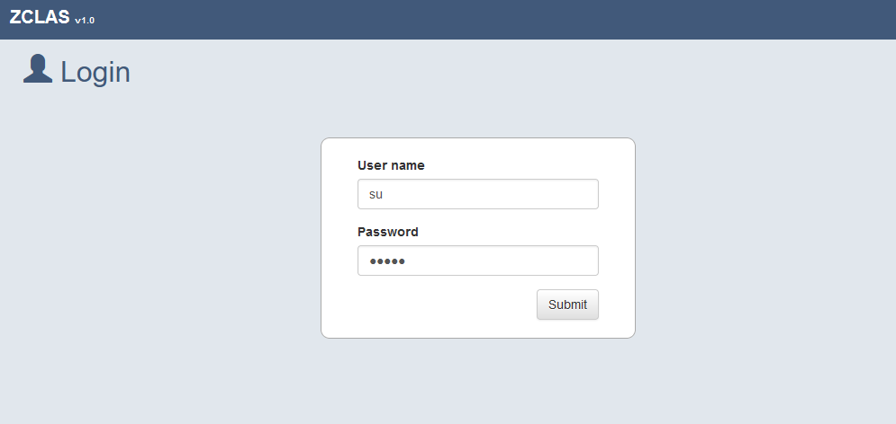

Figure 1 - Login page

Type user name and password and click “**Submit**” button. If you provided correct credentials, you will get into the system, otherwise an error message will be shown.

Once you get into the system, you will see your name in the right top corner of the window. Next to your name, you can find logout icon, which can be clicked to exit from the system.



Figure 2 – Page header after login

Do not leave system open under your account and always logout after finishing your work. If you leave it opened, someone can use it under your name and do changes.

# System settings

System setting allow certain flexibility in configuring ZCLAS application. They can be used to define default map extent, coordinate system, allowed file type and others. Start accessing system setting through the main menu **Administration → Settings**.

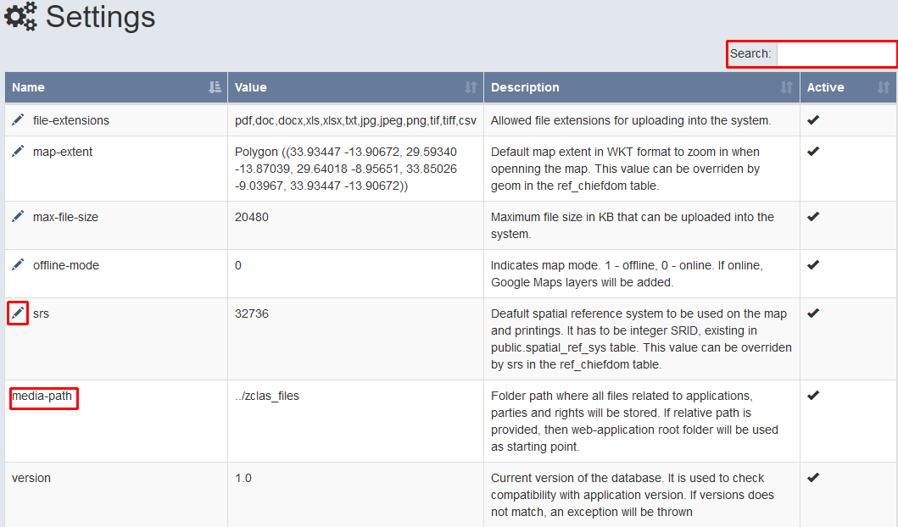

Figure 3 – System settings page

On this page you can do a quick search, using search text filed on the right side above the settings table, edit specific setting by clicking pencil icon in front of setting name. The table contains 4 columns:

1. **Name** – Setting name. Must be unique.
2. **Value** – Actual setting value.
3. **Description** – Description of the setting.
4. **Active** – Boolean flag indicating if it is active and should be used by the system.

You can also note that some of the settings do not have editing icon (e.g. **media-path**). This is because such settings are very important and not supposed for modification. If modification is needed, it will done along with source code changes.

For changing setting value, simply click pencil icon in front of the setting name.

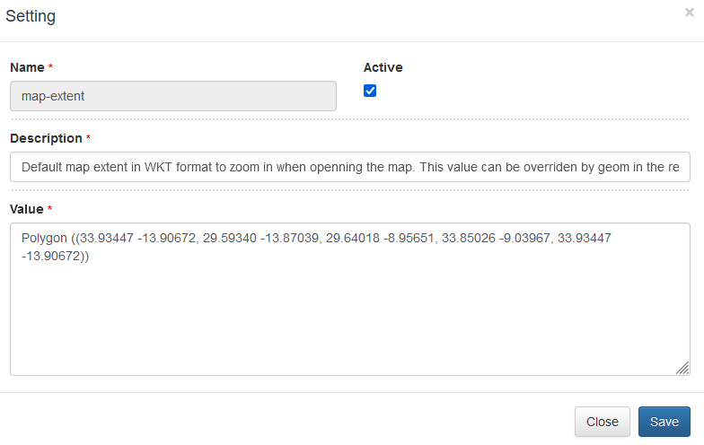

Figure 4 –Setting editing window

Make required changes and click **Save** button to apply changes.

# User Groups

All users in the system must belong at least to one group. Multiple groups can be assigned as well. User group is used for grouping different user by their role. For instance, Front Office group is for those users who receive applications from clients and returns output results at the final stage. Actual access permissions are assigned to a group in order to make it easier, avoiding per user assignment. Start accessing user groups through the main menu **Administration → Security → Groups**.

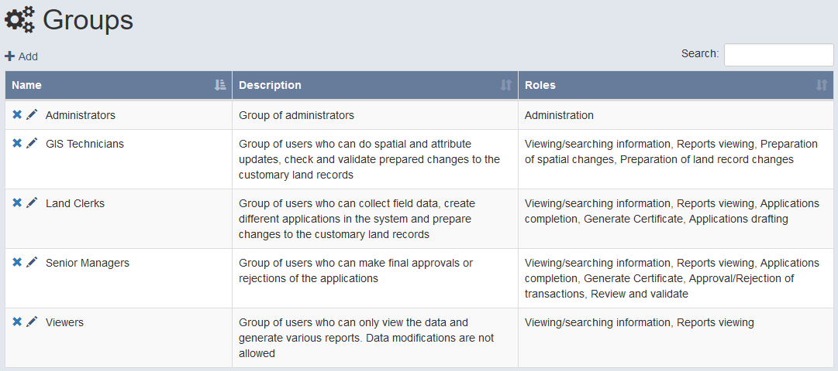

Figure 5 – User groups page

These groups are configured by default and can be adjusted as per local requirements. On the **Groups** page you can do a quick search, using search text filed on the right side above the table, edit or delete specific group by clicking pencil/delete icon in front of group name or add a new group using “**+ Add**” link.

The table contains 3 columns:

1. **Name** – Group name. Must be unique.
2. **Description** – Short description of the group.
3. **Roles** – List of roles, assigned to the group and separated by comma.

For adding new group, simply click “**+ Add**” link above the table.

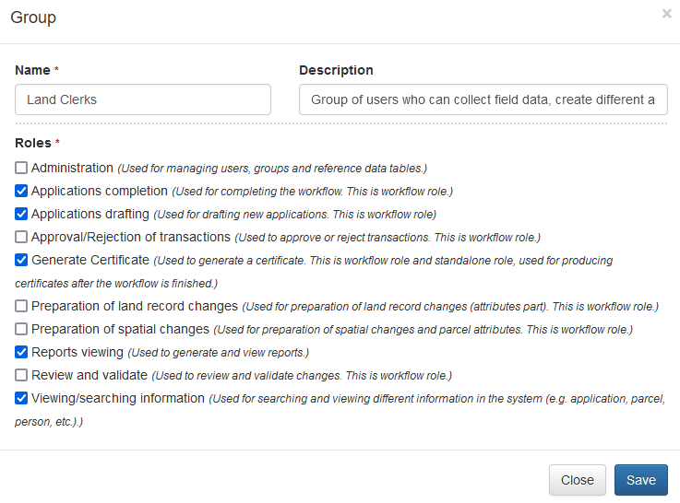

Figure 6 – New user group

Enter group name and select one or multiple roles. Click **Save** button to add new group.

The following roles are available for selection:

* **Administration** – Used for managing users, groups and reference data tables.
* **Applications completion** – Used for completing the workflow. This is workflow role.
* **Applications drafting** – Used for drafting new applications. This is workflow role.
* **Approval/Rejection of transactions** – Used to approve or reject transactions. This is workflow role.
* **Generate Certificate** – Used to generate a certificate. This is workflow role and standalone role, used for producing certificates after the workflow is finished.
* **Preparation of land record changes** – Used for preparation of land record changes (attributes part). This is workflow role.
* **Preparation of spatial changes** – Used for preparation of spatial changes and parcel attributes. This is workflow role.
* **Reports viewing** – Used to generate and view reports.
* **Review and validate** – Used to review and validate changes. This is workflow role.
* **Viewing/searching information** – Used for searching and viewing different information in the system (e.g. application, parcel, person, etc.).

Group editing is similar to creating a new group and the same window is used. For deleting a group, use delete icon. Make sure that all users are removed from the group first (see Users chapter), before deleting the group.

# Users

User account must be created in order to access the system. Every user must belong at least to one group. Multiple groups can be assigned as well. Apart from defining user credentials and groups it belong to, the form allows also defining user access to chiefdom(s), which controls access to the land records relevant to selected chiefdom(s). Start accessing users through the main menu **Administration → Security → Users**.

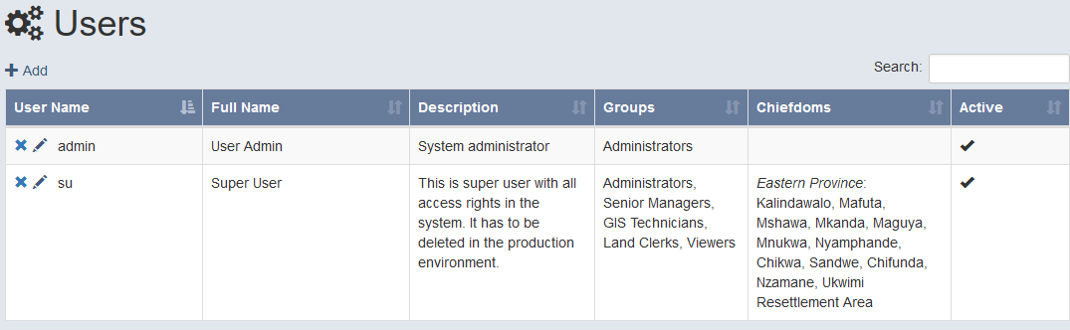

Figure 7 – Users page

On the **Users** page you can do a quick search, using search text filed on the right side above the table, edit or delete specific user by clicking pencil/delete icon in front of user name or add a new user using “**+ Add**” link.

The table contains 6 columns:

1. **User Name** – User name, used for accessing the system. Must be unique.
2. **Full Name** – Full name of the user.
3. **Description** – Short description of the user.
4. **Groups** – List of group, assigned to the user and separated by comma.
5. **Chiefdoms** – List of chiefdoms, assigned/accessible to the user.
6. **Active** – Boolean flag, indicating whether user account is active or not (can login)

For adding new user, simply click “**+ Add**” link above the table.

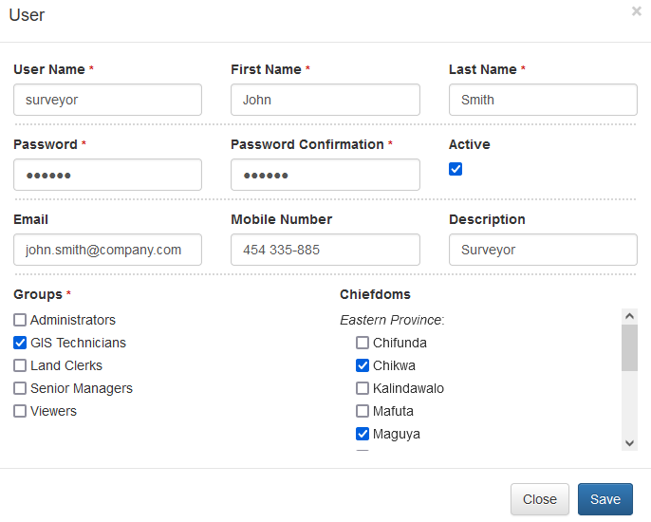

*Figure 8 – New user*

Fill in all fields, marked with red asterisk, select at one or multiple groups and select one or multiple chiefdoms. Click **Save** button to add new user.

User editing is similar to creating new user and the same window is used. For deleting a user, use delete icon.

**It is not recommended deleting a user, who already worked in the system and made any changes (e.g. created application or rights registration records). If the user does not work in the office any longer, make his/her account inactive (use Active checkbox). All modification actions in the system are logged, capturing user name and time of event. If the user deleted, log records will be able to show only its user name, but not real full name. Therefore, account deactivation must be considered over user deletion.**

# Map Layers

Different map layers can be configured for the Map component, used in the system. The list of layers should be considered as a catalog. New layers added here will not automatically appear on the map. Once a layer is created, it should be referenced in the chiefdom settings (see Chiefdoms chapter). In this way, a different set of layers can be configured for every chiefdom.

Currently only WMS layers are supported. Start accessing map layers through the main menu **Administration → Map Layers**.

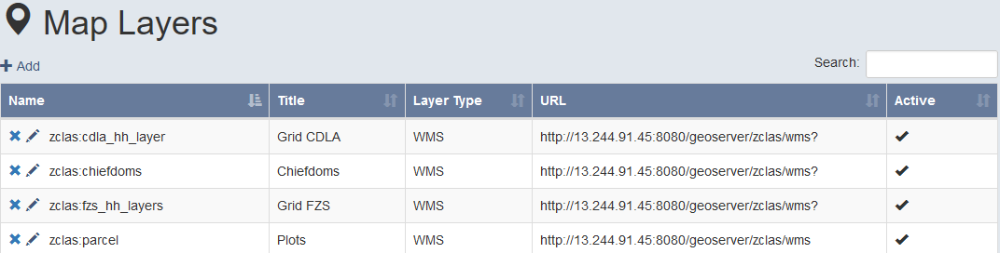

Figure 9 – Map Layers page

On the **Map Layers** page you can do a quick search, using search text filed on the right side above the table, edit or delete specific layer by clicking pencil/delete icon in front of layer name or add a new layer using “**+ Add**” link.

The table contains 5 columns:

1. **Name** – Map layer name, as it is configured on the map server.
2. **Title** – Layer title, which will be displayed in the legend.
3. **Layer Type** – Type of the layer.
4. **URL** – URL to the service.
5. **Active** – Boolean flag, indicating whether the layer is active or not

For adding new map layer, simply click “**+ Add**” link above the table.

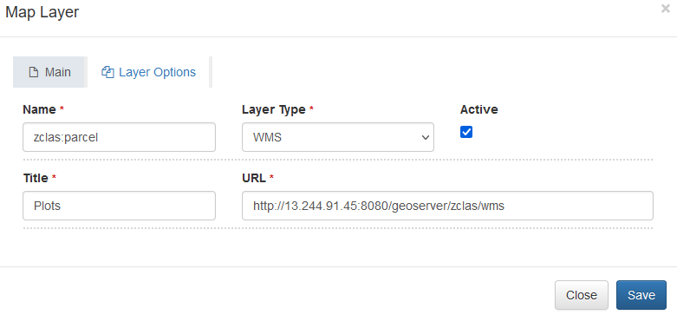

*Figure 10 – New map layer – Main tab*

Fill in all fields, marked with red asterisk and provide optional fields is needed. For configuring additional options, switch to **Layer Options** tab.

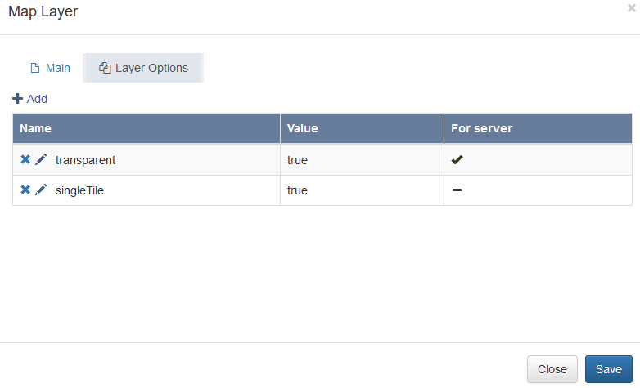

*Figure 11 – New map layer – Layer Options tab*

Finally click **Save** button to add new map layer. User editing is similar to creating new layer and the same window is used. For deleting a layer, use delete icon.

There are 2 types of layer options that can be used. First type are instructions for map server – “**For server**” is true. Those options can be found in GeoServer documentation (<https://docs.geoserver.org/2.22.x/en/user/services/wms/vendor.html>). Another type of options is for the map component itself – “**For server**” is false. The list of options can be found in the OpenLayers documentation (<https://openlayers.org/en/latest/apidoc/module-ol_layer_Base-BaseLayer.html>).

Below are few example of useful options you may use often:

|  |  |  |
| --- | --- | --- |
| **Option name** | **For map server** | **Description** |
| transparent | Yes | Request the image returned by GeoServer to be transparent in the empty areas. This option must be set to **true** for feature layers (e.g. parcels, village boundaries, etc).  By default, this option is false and the layer will be returned as a background imagery. Therefore setting this option for background imagery is not required. |
| singleTile | No | This option, if set to **true** will request the map component to pull the image from GeoServer as a single image. Otherwise, if false or not configured, GeoServer will return multiple small images (tiles). Multiple tiles may affect displaying feature labels when zooming in and out. Setting this option to **true** will resolve it. |
| maxResolution | No | This option affects layer display based on zoom level. The smaller number is set (e.g. 50), the higher zoom level is required to show the layer. The maximum resolution (exclusive) below which the layer will be visible. The values should be integer.  It can be used to hide layer features at a small zoom level and show it when user zooms in. |

# Reference data tables

Many different dropdown lists can be found on various forms in the system. For populating such lists, reference data tables are used. Most of such tables can be managed from administration to add, edit or delete values. Since all reference data tables have similar structure, we describe one full example in this chapter. Select main menu **Administration → Reference Data → Land and tenure → Document Type**.

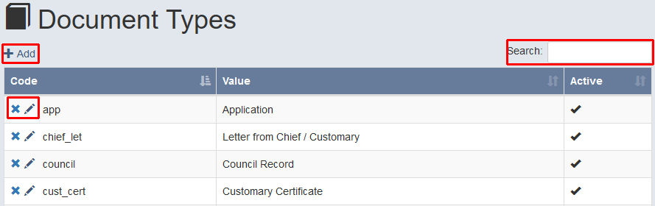

Figure 12 – Document Type page

Similar to other administration forms, on the **Document Types** page you can do a quick search, using search text filed on the right side above the table, edit or delete specific item by clicking pencil/delete icon in front of item name or add a new item using “**+ Add**” link.

There are 3 columns in most of the reference data tables:

1. **Code** – Unique code (ID) of the item.
2. **Value** – Actual value, which will be displayed in a dropdown list.
3. **Active** – Boolean flag, indicating whether the item is active or not (displayed in a dropdown list)

For adding new item, simply click “**+ Add**” link above the table.

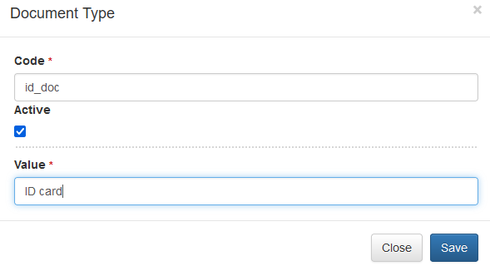

*Figure 16 – New document type*

Fill in all fields, marked with red asterisk and click **Save** button to add new item. Editing is similar to creating new item and the same window is used. The only difference is that the **Code** field cannot be modified.

For deleting an item, use delete icon. Make sure that if the item you want to delete is used in some existing records (e.g. application), the deletion will not be possible. In such case if you still want to remove the item, you have deactivate it by removing **Active** checkbox. After that for all new records, deactivated item will not be visible in dropdown lists, while old records using it will be able to display its value.

As it was mentioned above, all reference data tables have the same logic of managing them. The only small difference can be found on the **Chiefdoms**, **Areas** and **Villages** forms, where records have to be filtered first by selecting province, chiefdom and area (for villages).

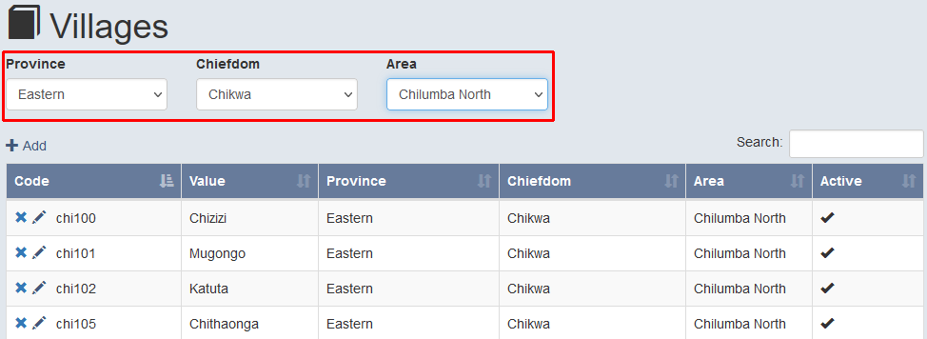

*Figure 14 – Province, Chiefdom and Area are selected to get villages list*

# Chiefdoms

Chiefdoms play an important role in the system. They are used to define data access for system users, configure map layers that will be visible for a specific chiefdom and set additional parameters that are used for generating ownership certificates. Users, assigned to one or multiple chiefdoms will be able to see and search only those land records, which are relevant to the assigned chiefdoms.

For accessing chiefdoms, select **Administration → Reference Data → Administrative Divisions → Chiefdoms**. You will have to filter chiefdoms by the province.

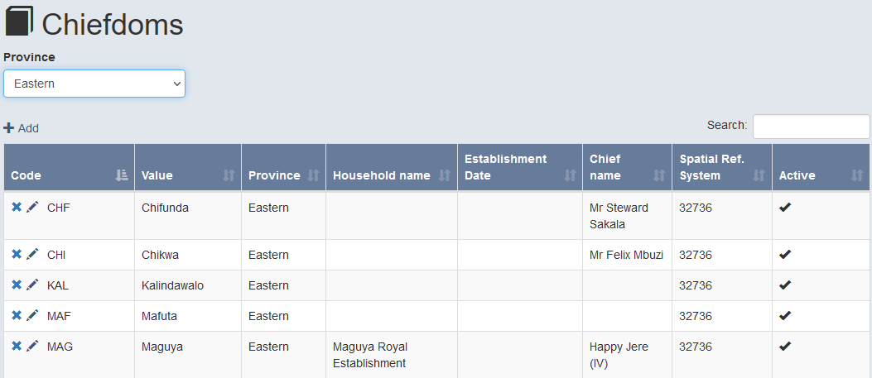

*Figure 15 – List of Chiefdoms*

For adding new chiefdom click “**+ Add**” link above the table or use edit (pencil icon) no modify existing.

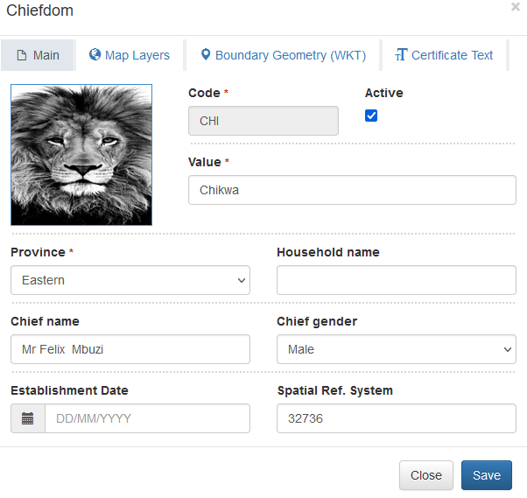

*Figure 16 – Chiefdom Main tab*

Enter unique chiefdom code, value (chiefdom name) and select province. Additionally you can provide chief’s name, gender and establishment date.

Spatial reference system allows configuring coordinates system for this chiefdom. It is used for generating a parcel map and show coordinates in this system. It should be an integer number from the EPSG database (<https://epsg.io>). It can be also found in the ZCLAS database under public schema, **spatial_ref_sys** table (**srid** column). If spatial reference system is not defined, then **srs** value from the system settings will be used.

If a chiefdom has a logo, it can be added on the Main tab as well. It is recommended to use square shape with approximate size of 100x100 pixels.

Switch to the “Map Layers” tab to configure map layers, which will be visible on the map component for this specific chiefdom.

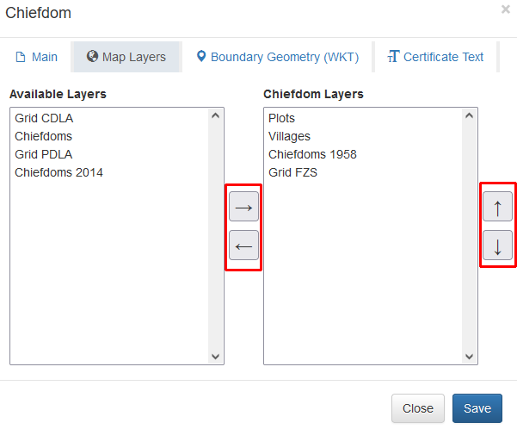

*Figure 17 – Chiefdom Map Layers tab*

Select layers from the “Available Layers” list and use “→” to add them to the chiefdom layers. Use up “↑” and down “↓” arrows to change layers order. For removing a layer, select it in the list of chiefdom layers and click “←” arrow.

Switch to the “Boundary Geometry (WKT)” tab to configure chiefdom boundary. This information can used for creating chiefdoms layer to show their boundary and it is also used as a map extent when opening map component.

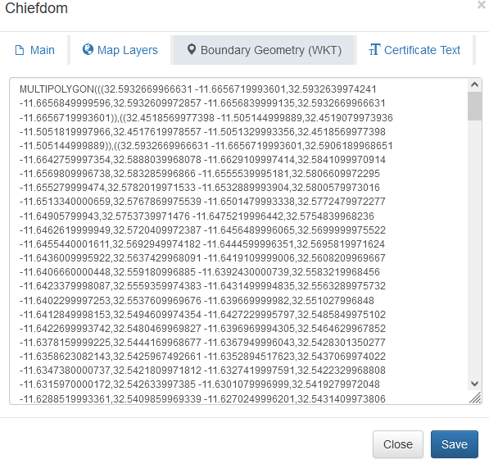

*Figure 18 – Chiefdom Boundary Geometry tab*

The value should be provided in the well-known text (WKT) using WGS84 coordinates. It can be easily transformed from shapefile or other vector data using external GIS software.

Finally go to the “Certificate Text” tab to provide custom text for the ownership certificate, used on the second page.

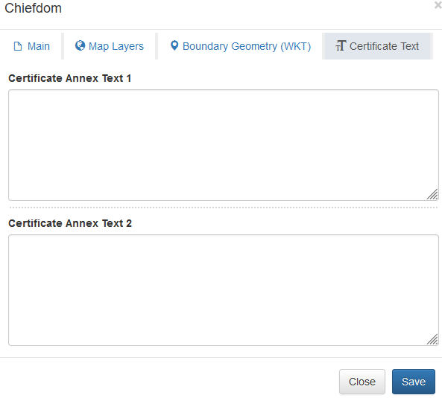

*Figure 19 – Chiefdom Certificate text tab*

If custom text is not provided, the default value will be used. The following image shows default text on the certificate, which can be changed through the “Certificate Annex Text 1” and “Certificate Annex Text 2” values.

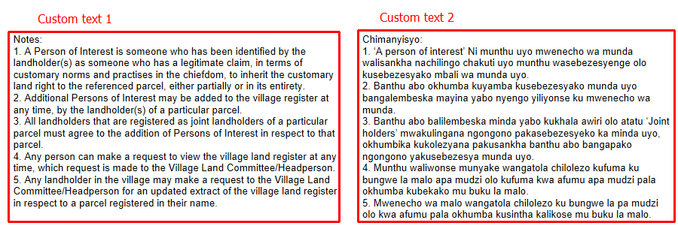

*Figure 20 – Certificate text that can be configured*

Click **Save** button to save the chiefdom. Editing is similar to creating a new item and the same form is used. For deleting the chiefdom, use delete icon. Deleting will not be possible if the chiefdom is already used in some records. Instead, you can deactivate it by removing **Active** checkbox. It will stay visible for existing records, but not allowed for selection on new records.